NMD 100
Note and Media Dispenser
Product Datasheet & Integration Reference
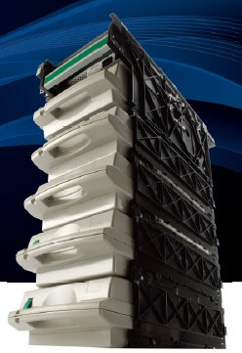
Modular • Scalable • High-Reliability ATM Banknote Dispenser
Product Overview
The NMD 100 (Notes and Media Dispenser) is a high-performance, modular banknote dispensing system developed by De La Rue for ATM integration. Designed for reliability and flexibility, the NMD 100 supports 1 to 8 denominations in a single chassis and can be configured for front or rear service access. Its stackable denomination extension (DE) architecture makes field upgrades simple without major cabinet modifications.

Key Features
- Supports 1 to 8 Note Cassettes — handles up to 8 different denominations simultaneously
- Modular, stackable architecture — field-upgradable with Denomination Extension (DE) kits
- Front service and rear service configurations available
- High-capacity cassettes with secure locking mechanism
- Integrated Reject Vault for sorted note rejection
- Note Qualifier (NQ) module for accurate banknote authentication
- Central Machine Controller (CMC 200) with RS-232C communication interface
- Parallelism-guided installation for precise cabinet alignment
- Compatible with most ATM cabinet formats via slide mounting system
- ESD protection on all internal inter-module connections

Product Gallery
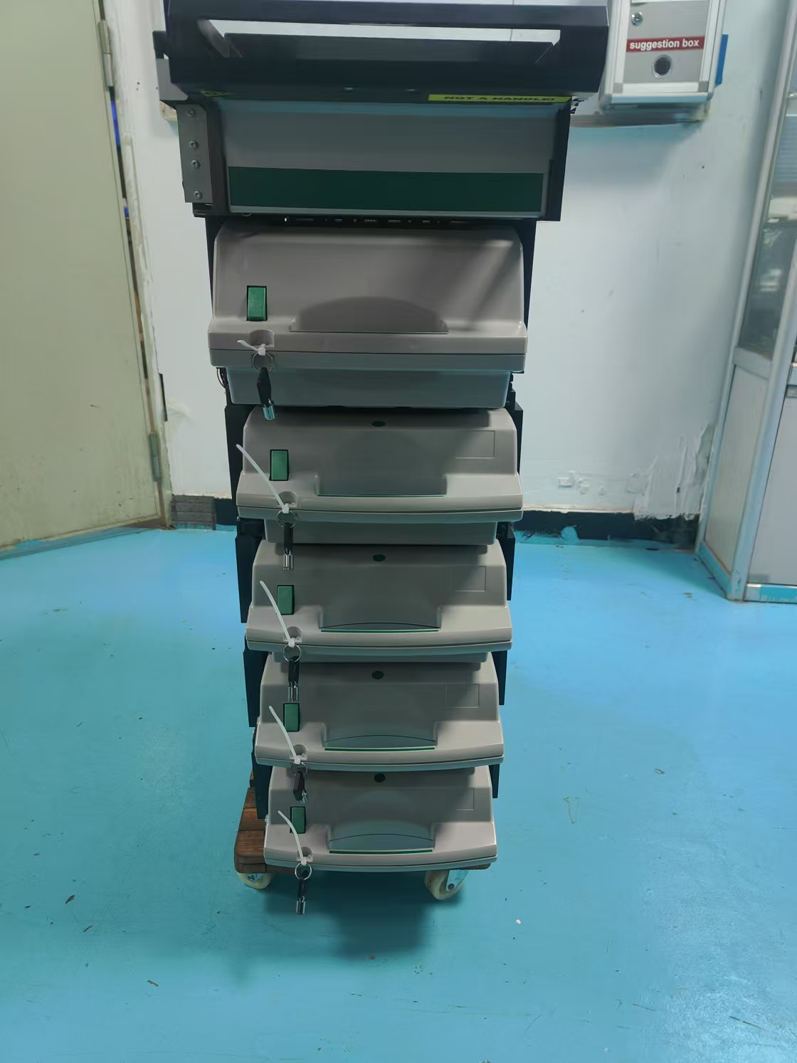  Front View — Cassette Side | 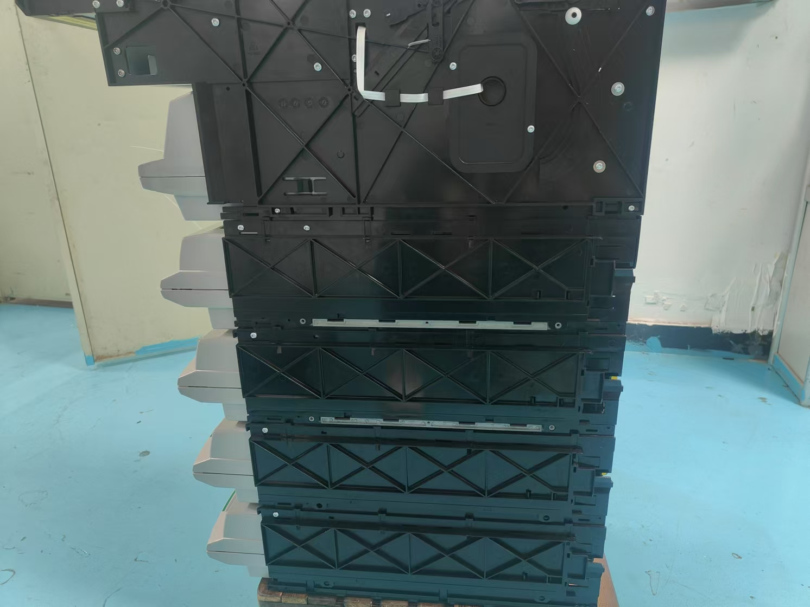  Rear View — Service Side

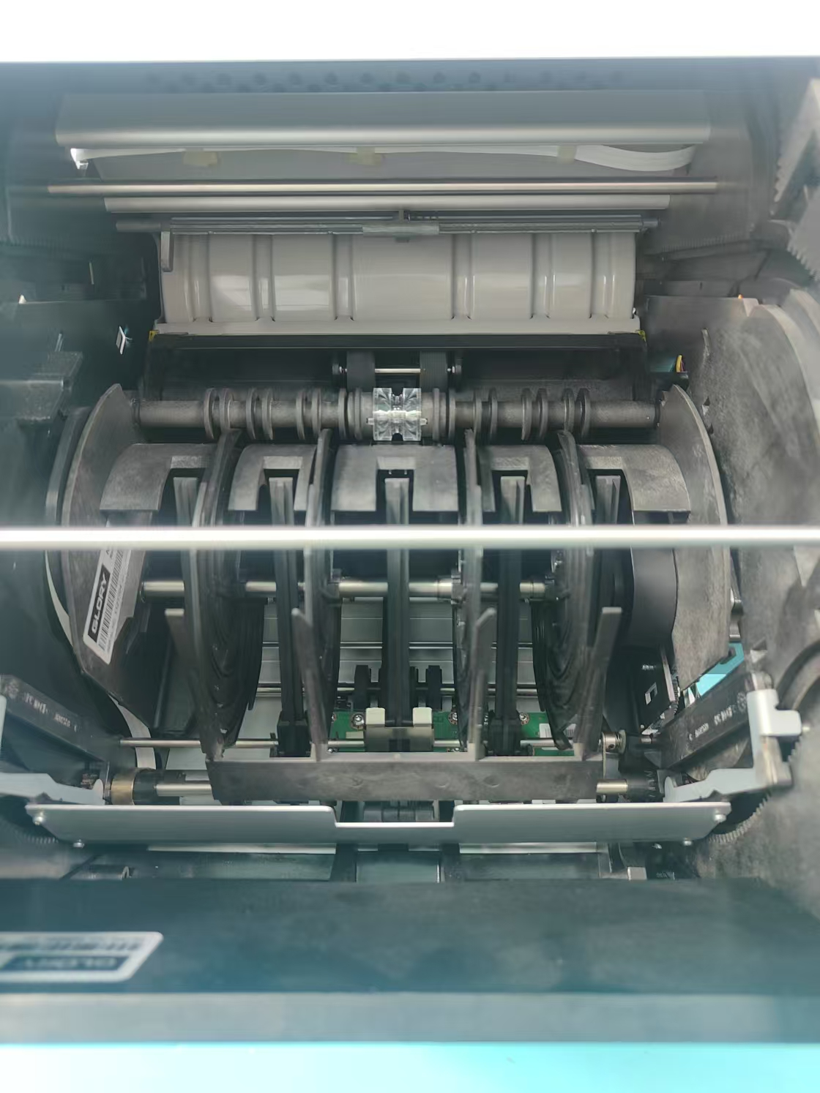  Internal Transport Mechanism | Multi-Cassette Configuration (up to 8DN)

Technical Specifications
Weight & Physical Dimensions
Standard 2DN NMD (with empty cassettes & RV) | 22.7 kg
Additional denomination (DE kit) | 2.6 kg per unit
Note Cassette (without notes) | 2.9 kg
Reject Vault (without notes) | 2.0 kg
NMD Base Width | 366.6 ± 1 mm
NMD Height (2DN configuration) | Approx. 449.5 mm (85 mm ext.)
NMD Depth | Approx. 240 mm
Delivery Slot Width | 144 ± 0.2 mm

Power Supply
Mains Input Voltage | 120 – 240 VAC (nominal)
Input Current | 0.8 – 2.0 A
Frequency | 50 – 60 Hz
Mains Connector | IEC-320 Type T65
DC Distribution | From integrated Power Supply to all modules

Communication Interface
Standard | RS-232C
Connector (NMD side) | CT 5-pin, AMP 173 977-5
Connector (Host side) | D-SUB 9-pin, AMP 748 047-1 (shielded)
Cable | AWG26 × 6, shielded
Protocol | De La Rue CCRM NMD 100 (Doc. 8030676)
Handshaking | With or without hardware handshaking

Shutter Control Interface
Connector Type | AMP CT, P/N 176125-8
Reference Document | DLR Document D003242
Location | CMC 200 board
Cable (if own shutter) | AMP 173 977-8, AWG 26 recommended

Installation & Mounting
Service Access Modes | Front service or rear service
Mounting Method | Side-mounting with parallel slides (pull-out capable)
Parallelism Requirement | Max. 1.0 mm difference between mounting points at same axis
Horizontal tolerance | ± 50 mm
Min. front clearance (refill) | 500 mm
Cassette Configuration | 1 to 8 Note Cassettes (up to 8 denominations)
Extension Method | DE (Denomination Extension) kits — field upgradable

Door Control PCB — ATK DOOR-V1.1
The ATK DOOR-V1.1 is the controller board for the dispensing door mechanism. It interfaces with the host via RS-232 and manages motor control, sensor inputs, and power distribution.

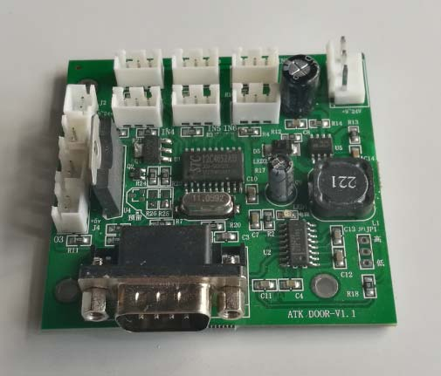  ATK DOOR-V1.1 PCB | 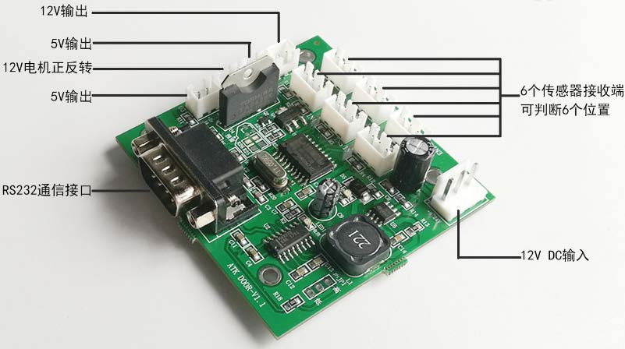  ATK DOOR-V1.1 — I/O Port Annotations

ATK DOOR-V1.1 Interface Specification
Power Input | 12 V DC
Power Outputs | 12 V output × 1, 5 V output × 2
Motor Control | 12 V motor forward/reverse (H-bridge)
Sensor Inputs | 6 × sensor receiver ports (6-position detection)
Communication | RS-232 interface (DB-9 connector)
Board Dimensions | Approx. 100 × 85 mm
PCB Version | ATK DOOR-V1.1

Roll Shutter Mechanism — 17010
The 17010 roll shutter provides the dispensing aperture security mechanism, integrating with the ATK DOOR-V1.1 controller board.

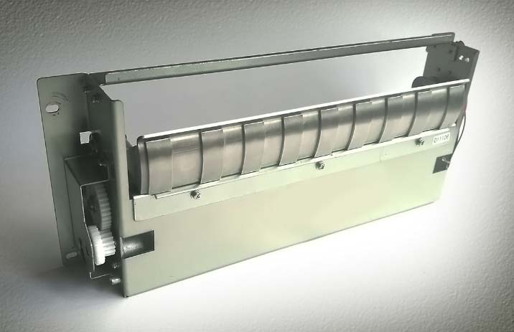  Roll Shutter Assembly (17010) | 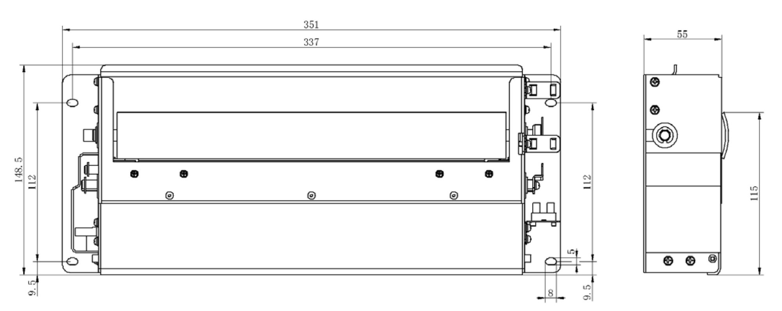  Roll Shutter Dimensional Drawing

Roll Shutter Dimensional Specification
Overall Width | 351 mm
Body Width | 337 mm
Overall Height | 148.5 mm
Aperture Height | 112 mm
Depth (side view) | 55 mm
Side Profile Height | 115 mm
Mounting Offset (bottom) | 9.5 mm
Slot Width | 8 mm
Slot Offset | 9.5 mm
Drive Gear | Left side, motor-driven via ATK DOOR-V1.1

System Architecture
The NMD 100 is composed of modular sub-assemblies that can be stacked and combined for flexible denominations. The following diagram describes the module hierarchy.

NMD 100 Module Hierarchy
Stack Presenter (SPF/SPR) | Presents stacked notes to the customer via delivery slot
Bundle Carriage Unit (BCU) | Transports bundled notes from sorter to presenter
Bundle Outlet Unit (BOU) | Manages exit path to delivery chute
Note Stacker (NS) | Accumulates notes for batch dispensing
Note Qualifier (NQ) | Authenticates and validates notes during transport
Note Feeder (NF) | Picks individual notes from the cassette
Frame (FR) | Main structural chassis housing all modules
Central Machine Controller (CMC 200) | Main control board — RS-232 host interface, power management
Reject Vault (RV) | Secure lockable container for rejected notes
Note Diverter (ND) | Routes notes between denomination paths
Denomination Extension (DE) | Adds additional cassette support — field installable
Note Cassette (NC) | Lockable removable cassette for each denomination
Note Feed Controller (NFC) | Sub-controller per denomination layer

Configuration Options
Cassette Options
Minimum Configuration | 1 × Note Cassette + 1 × Reject Vault
Standard Configuration | 2–4 denominations
Maximum Configuration | 8 denominations (via DE kits)
Note Cassette Capacity | Varies by model (see NC product specifications)
Cassette Security | Customer-selectable lock coding
Service Configuration
Rear Service | Default — cassettes and service from rear of cabinet
Front Service | Optional — cassettes accessible from ATM front
Extension Kits
DE Kit (1 addition) | Adds 1 denomination — includes NF, NFC, DE frame, NC
Note Cassette Coding | Refer to Service Manual 8030666

Compliance & Safety
Safety & Compliance
ESD Protection | All inter-module and signal connections require ESD precautions during service
EMC Responsibility | System integrator responsible for EMC compliance
Cabinet Transport | NMD must be transported upright, cassettes removed, properly secured
Filter Connector | Recommended when RS-232 cable exits the cabinet
Reference Standards | Refer to De La Rue product specifications D018140 for full environmental specs

Reference Documents
Related Documentation
NMD 100 Integration Manual | Doc. No. 8030614/6-E (De La Rue)
NMD 100 Product Specifications | Doc. No. D018140 (De La Rue)
NMD 100 Getting Started Guide | Doc. No. 8030685 (De La Rue)
NMD 100 CCRM | Doc. No. 8030676 — Communication & Command Reference
NMD 100 Service Manual | Doc. No. 8030666 — Cassette Coding & Maintenance
Shutter Control Interface | DLR Document D003242
CashCode MSM Spec | Shenzhen Zhongkong, Material No. 13540040, V1.0

NMD 100 Product Datasheet | De La Rue Cash Systems | Talja Södra Industriområde, SE-642 84 Flen, Sweden
This document is compiled from official integration references and supplier specifications. For full technical data refer to De La Rue documents listed above.

